Ayush Goyal
190905522 CSE D Roll 62

Operating Systems Lab 4: File System

1. Write a program to find the inode number of an existing file in a directory. Take the input as a filename and print the inode number of the file.

Code:

#include<unistd.h>
#include<stdio.h>
#include<stdlib.h>
#include<sys/stat.h>
#include<sys/types.h>

int main(int argc, char const *argv[]){
if(argc < 2){
printf("Incorrect number of arguments, Expected 1, Got: %d\n",argc-1);
return 0;
}
struct stat file_stat;
int return_value = stat(argv[1], &file_stat);
if(return_value != 0){
perror("stat");
return 1;
}
printf("File: %s ---- Inode: %ld\n", argv[1], file_stat.st_ino);
return 0;
}

Output:

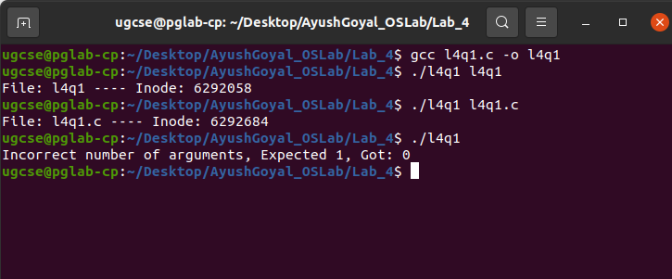

2. Write a program to print out the complete stat structure of a file.

Code:

#include<unistd.h>
#include<stdio.h>
#include<stdlib.h>
#include<sys/stat.h>
#include<sys/types.h>
#include<time.h>

const char *perms(__mode_t mode){
static char buf[16] = {0};
int i = 0;
//user permissions
buf[i++] = ((mode & S_IRUSR) ? 'r' : '-');
buf[i++] = ((mode & S_IWUSR) ? 'w' : '-');
buf[i++] = ((mode & S_IXUSR) ? 'x' : '-');
//group permissions
buf[i++] = ((mode & S_IRGRP) ? 'r' : '-');
buf[i++] = ((mode & S_IWGRP) ? 'w' : '-');
buf[i++] = ((mode & S_IXGRP) ? 'x' : '-');
//other permissions
buf[i++] = ((mode & S_IROTH) ? 'r' : '-');
buf[i++] = ((mode & S_IWOTH) ? 'w' : '-');
buf[i++] = ((mode & S_IXOTH) ? 'x' : '-');
return buf;
}

int main(int argc, char const *argv[]){
if(argc < 2){
printf("Incorrect number of arguments, Expected 1, Got: %d", argc-1);
return 0;
}
struct stat file_stat;
int return_value = stat(argv[1], &file_stat);
if(return_value != 0){
perror("stat");
return 1;
}
printf("File: %s\nInode: %ld\nDevice Container ID: %ld\nMode: %10.10s\nHard Links: %ld\nUser ID: %d\nGroup ID: %d\nDevice ID: %ld\nTotal Size: %ld\nBlock Size: %ld\nNumber of blocks: %ld\nLast Access Time: %sLast Modified: %sLast Status: %s", argv[1], file_stat.st_ino, file_stat.st_dev, perms(file_stat.st_mode),file_stat.st_nlink, file_stat.st_uid, file_stat.st_gid, file_stat.st_rdev, file_stat.st_size, file_stat.st_blksize, file_stat.st_blocks, ctime(&file_stat.st_atime), ctime(&file_stat.st_mtime), ctime(&file_stat.st_ctime));
return 0;
}

Output:

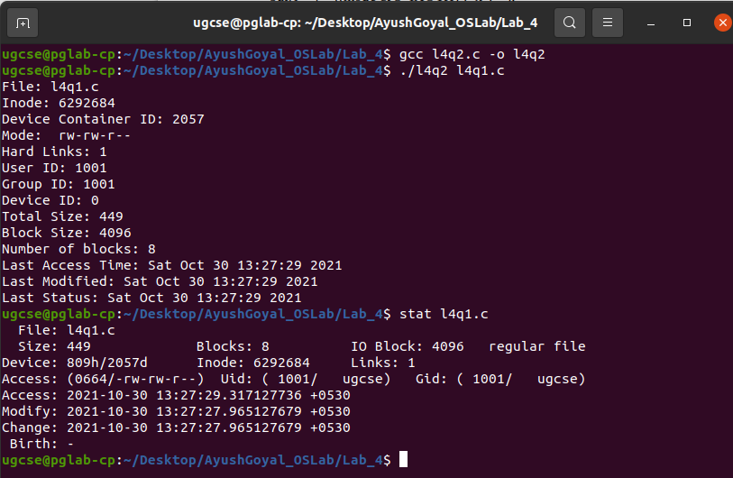

3. Write a program to create a new hard link to an existing file and unlink the same. Accept the old path as input and print the new path.

Code:

#include<unistd.h>
#include<stdio.h>
#include<stdlib.h>
#include<sys/stat.h>
#include<sys/types.h>

int main(int argc, char *argv[])
{
if(argc < 2){
printf("Incorrect number of arguments, Expected 1, Got: %d", argc-1);
return 0;
}
char *oldpath = argv[1];
char *newpath = "newpath.txt";
struct stat file_stat;
printf("Before linking new link:\n");
system("ls");
int return_value = stat(oldpath, &file_stat);
if(return_value != 0){
perror("stat");
return 1;
}
printf("Number of links before linking: %ld\n", file_stat.st_nlink);
link(oldpath, newpath);
printf("After linking new link:\n");
system("ls");
int return_value_2 = stat(newpath, &file_stat);
if(return_value_2 != 0){
perror("stat");
return 1;
}
printf("Number of links after linking: %ld\nThe new path is: %s\n", file_stat.st_nlink, newpath);
unlink(oldpath);
printf("After unlinking old link:\n");
system("ls");
int return_value_3 = stat(newpath, &file_stat);
if(return_value_3 != 0){
perror("stat");
return 1;
}
printf("Number of links after unlinking: %ld\n", file_stat.st_nlink);
return 0;
}

Output:

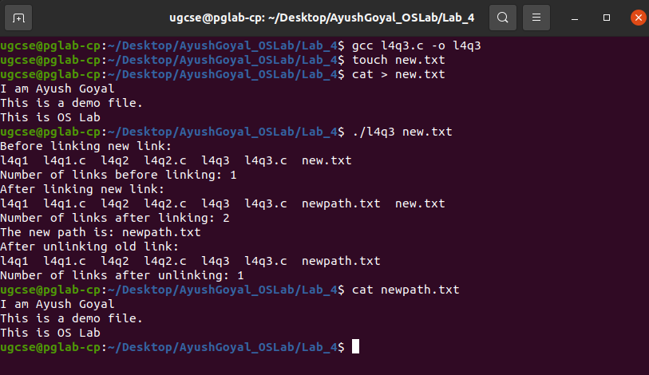

4. Write a program to create a new soft link to an existing file and unlink the same. Accept the old path as input and print the new path.

Code:

#include<unistd.h>
#include<stdio.h>
#include<stdlib.h>
#include<sys/stat.h>
#include<sys/types.h>

int main(int argc, char *argv[])
{
if(argc < 2){
printf("Incorrect number of arguments, Expected 1, Got: %d", argc-1);
return 0;
}
char *oldpath = argv[1];
char *newpath = "newpath.txt";
struct stat file_stat;
printf("Before linking new link:\n");
system("ls");
int return_value = stat(oldpath, &file_stat);
if(return_value != 0){
perror("stat");
return 1;
}
printf("Number of links before linking: %ld\n", file_stat.st_nlink);

symlink(oldpath, newpath);

printf("After linking new link:\n");
system("ls");
int return_value_2 = stat(newpath, &file_stat);
if(return_value_2 != 0){
perror("stat");
return 1;
}
printf("Number of links after linking: %ld\nThe new path is: %s\n", file_stat.st_nlink, newpath);
unlink(newpath);
printf("After unlinking new soft link:\n");
system("ls");
int return_value_3 = stat(oldpath, &file_stat);
if(return_value_3 != 0){
perror("stat");
return 1;
}
printf("Number of links after unlinking: %ld\n", file_stat.st_nlink);
return 0;
}
Output:

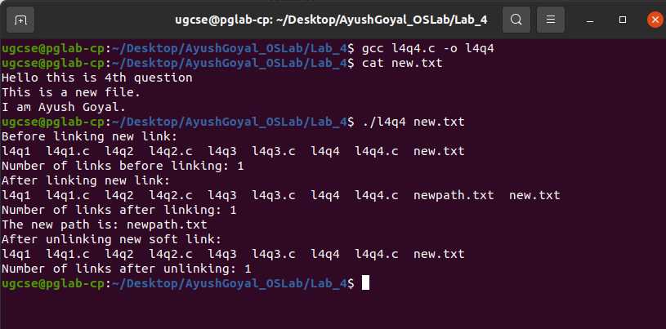

THE END

